Evaluation: ET-OvR
Accuracy: 0.9278481012658227
Precision: 0.9306432641313171
Recall: 0.9278481012658227
F1 Score: 0.9282496361816406
Jaccard Index: 0.868751580832633
Matthews CorrCoef: 0.9069780284350761
Cohen’s Kappa: 0.9063301513736373
Specificity: 0.9887569710430637
AUC: 0.9995691821641417
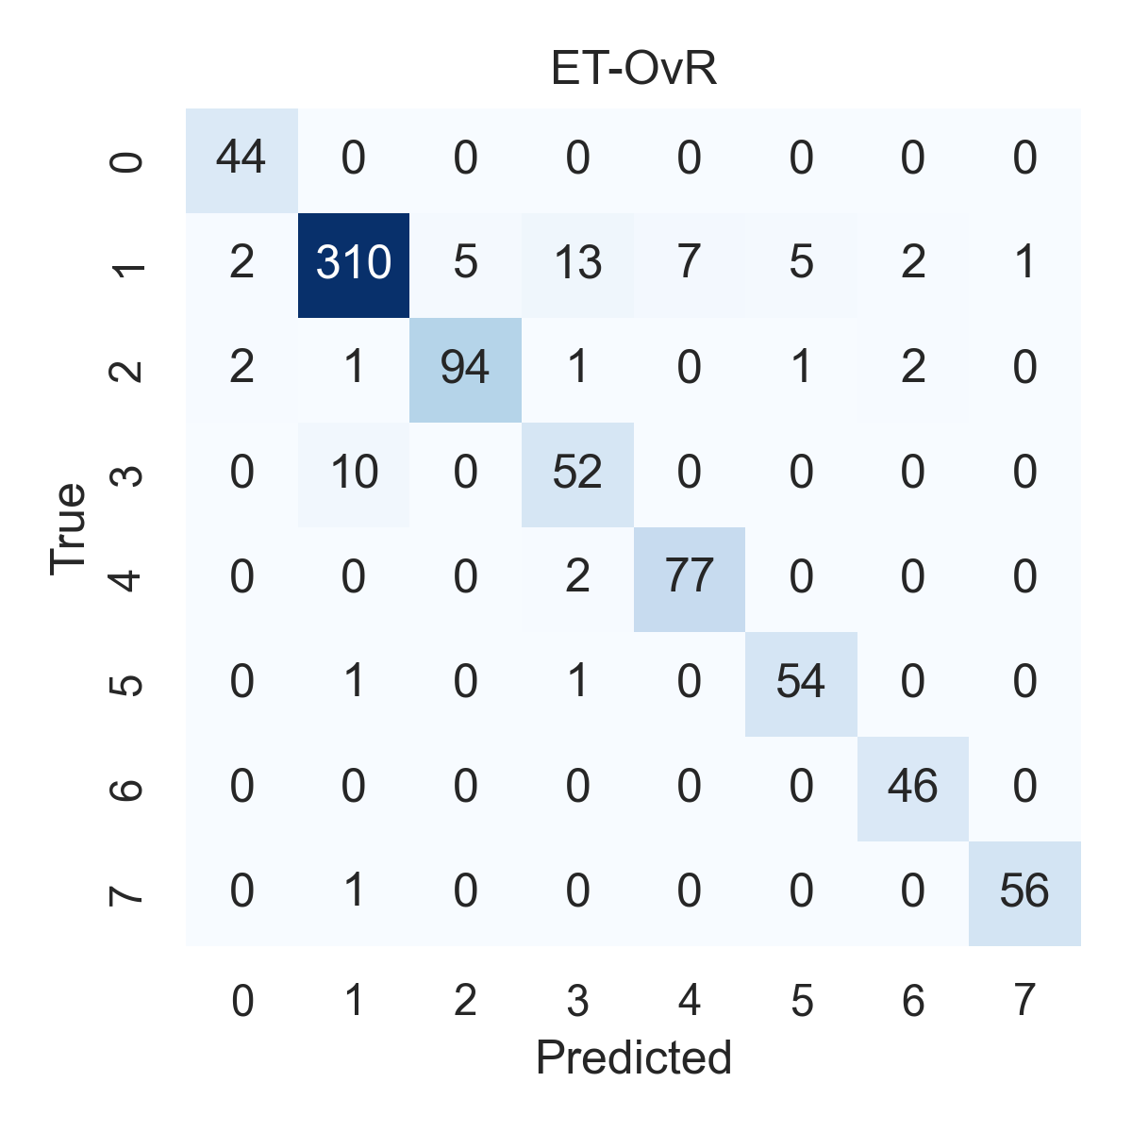

Combined ROC Curves
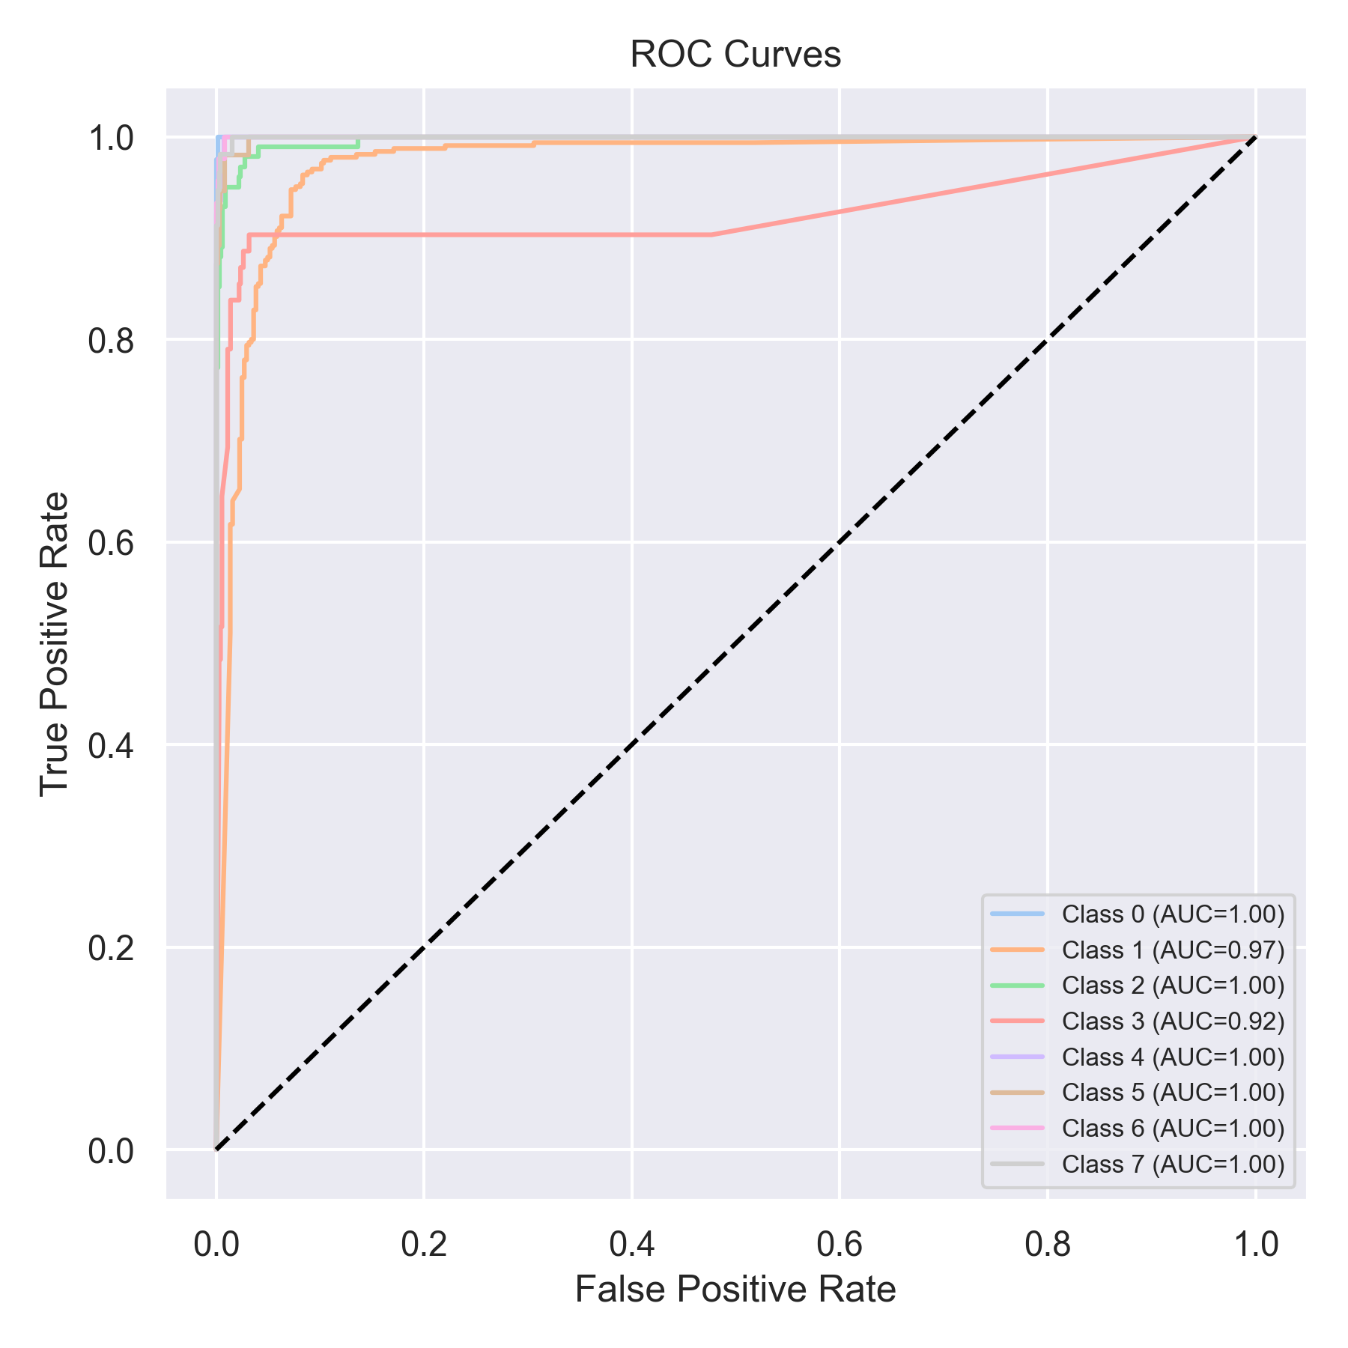

Evaluation: RF-OvR
Accuracy: 0.8974683544303798
Precision: 0.9049244545187732
Recall: 0.8974683544303798
F1 Score: 0.8981968269053011
Jaccard Index: 0.8180148916197149
Matthews CorrCoef: 0.8703895837220297
Cohen’s Kappa: 0.8683487739092328
Specificity: 0.9844073089879063
AUC: 0.9991144300040689
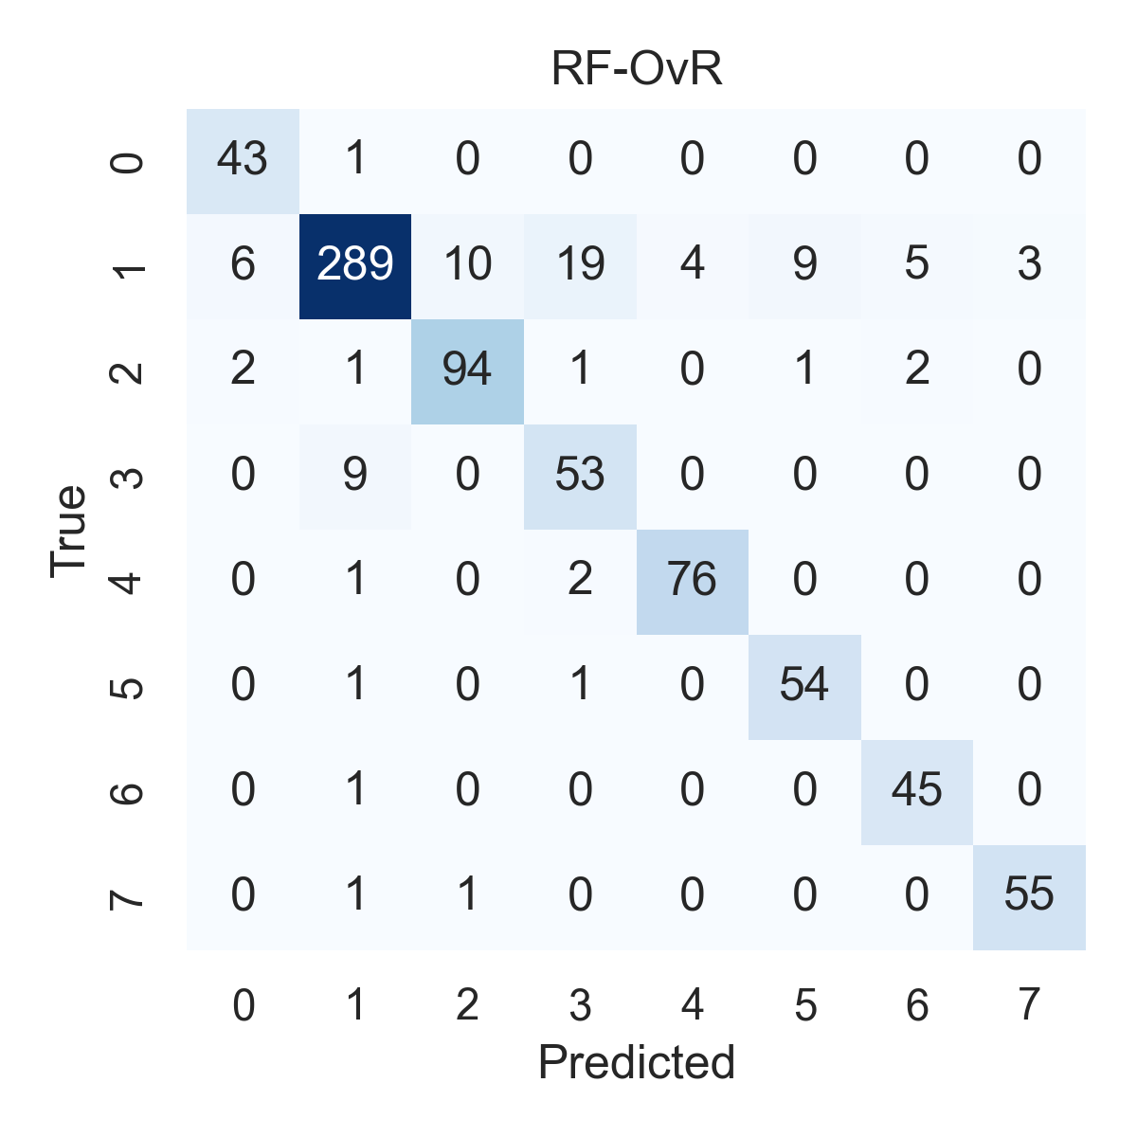

Combined ROC Curves
